Can you help?
The hops on the tennis courts on the Recreation Ground need pruning.
A work party will be tackling this task
on
MONDAY 9th DECEMBER AT 9.30
Please come and help.
Please meet at the Rec with your gloves and secateurs
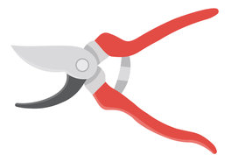
For more information or to say you can come please ring the
Parish Council Clerk 01 483 479312
(You can just turn up)

