

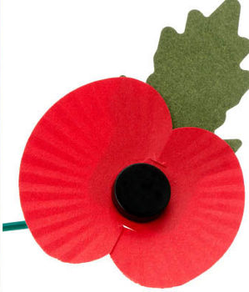

Remembrance
Day Parade

Sunday 10th November 2024

at Send village

- 2:30pm – meet at the Recreation Ground near the War Memorial (corner with Sandy Lane)
- 2:45pm – short parade to Lancaster Hall
- 3:00pm – remembrance service in Lancaster Hall
- 3:30pm – parade to War Memorial at Church Rooms
- 3:40pm – at War Memorial, wreath laying and last post
- 4:00pm – refreshments will be served afterwards at Lancaster Hall.

The Mayor of Guildford and MP Zoe Franklin will be in attendance.

