Thank you everyone who helped with the Litter Pick and planting daffodils on Saturday 5th Oct.
It was good to have people of different ages helping with this community event.
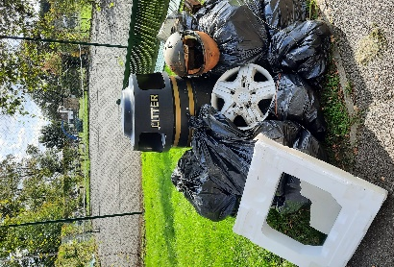
We collected lots of rubbish and planted lots of bulbs on the Rec.
Thank you again to Edwins for help with the cost of the bulbs and The Astalet Café for providing us with coffee
Thank you, also to those residents of Send who regularly and independently litter pick.
Send Parish Council 


