
Tree Planting Day
in memoriam of Queen Elizabeth II Platinum Jubilee

www.sendparishcouncil.gov.uk

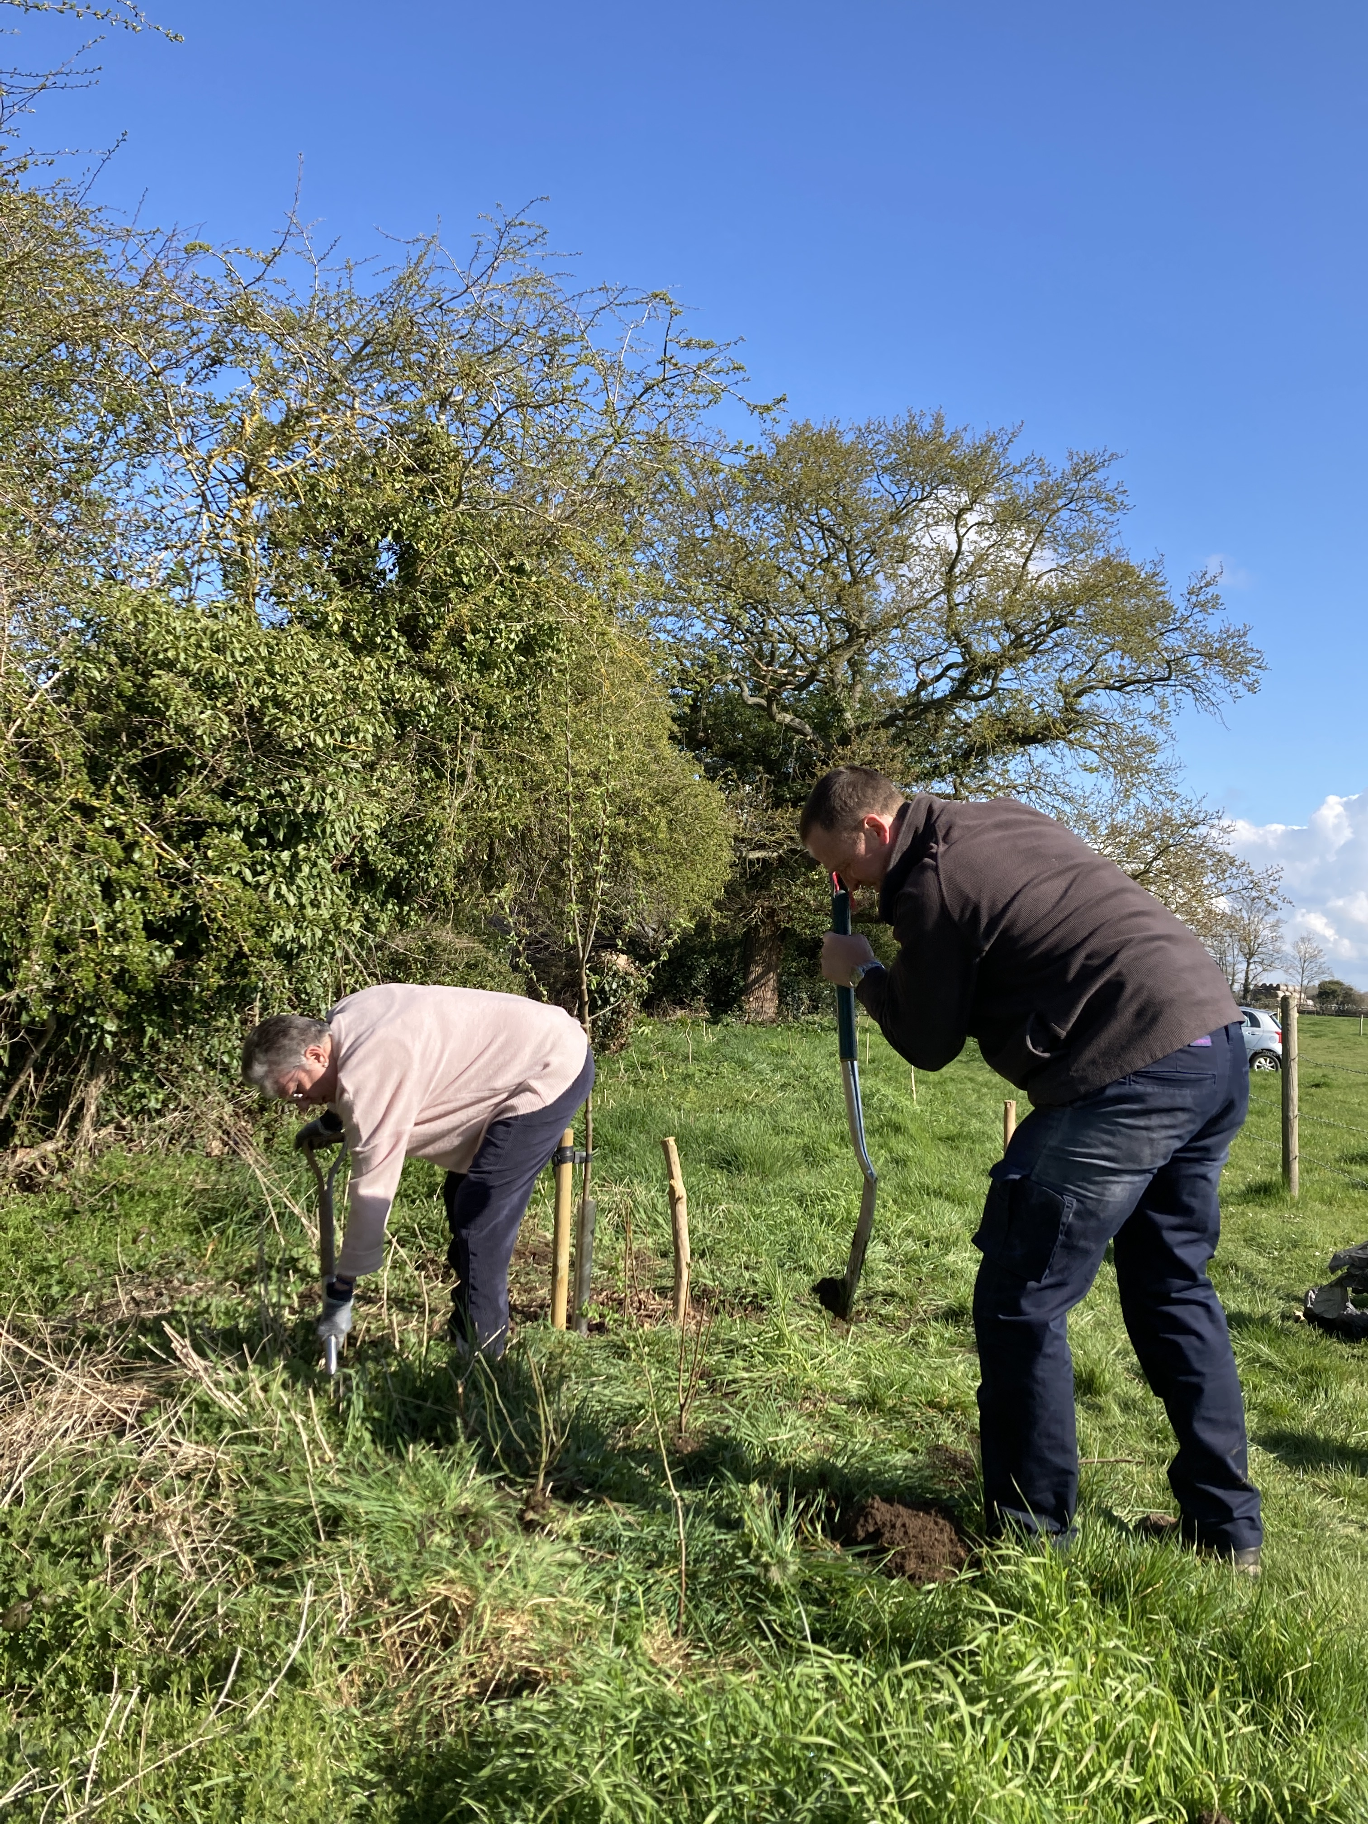

@ various locations in Send & Burnt Common
Saturday 28 January 2023   9:30am (end latest 12:30pm).

No prior experience required.
Your help & skills are appreciated –
please join us. Meet at Lancaster Hall if unsure of planting location.

In advance, please let us know you if you are interested and email clerk@sendparishcouncil.gov.uk or call 01483-479312 or mobile 07902 915241 by this Friday afternoon.
Please let us know your name and where within Send PC you live and we try and allocate you a suitable planting location with a lead team member.
Note: recommended are sturdy footwear, tough gloves and warm clothing. If you can, please bring some tools with you: secateur, spade and fork, large bag or bucket to move compost materials from nearby heap, lump hammer.

This tree planting event is part of the Send Parish Council’s quest to plant 70 trees in memoriam of our late Queen Elizabeth II and her Platinum Jubilee celebration in 2022. As such the trees planted will add to the nationwide Queen’s Green Canopy quest aiming for 1 million trees.
The trees have been kindly provided for free by Surrey County Council as part of their quest to plant a tree for every resident by 2030 – i.e. 1.2million trees for Surrey.

Locations:
- Bush Lane Nature Reserve – GU23 7HR – Send Hill, meet opposite junction with Sandfields – 18 trees,
- Triangular Green at Woodhill – GU23 7JR – on green opposite Doctors’ Surgery at Send Barns Lane – 17 Trees,
- Maple Road Play Area – GU23 6JY – near 51 Maple Road (Burnt Common) – 8 Trees.

The trees provided are all native tree species and will benefit wildlife within the village.
Tree supply is limited and planting will need to be undertaken on first come, first serve basis.

